Adopt –a – Robot: Questions to Answer

Group Roles
Recorder / Notetaker: __________________________________
Designer / Creator: __________________________________ & __________________________________

Presenter: __________________________________

Please answer these 10 questions and then create a presentation using Prezi or Glogster.
- What task does the robot perform? What human function or task does this robot simulate?

- Where is the robot used? What is its work envelope (how many degrees of freedom or flexible joints does it have)?

- Is the robot multi-functional? If so, what other tasks can it perform?

- How is the robot taught to perform its task?

- What sensors does the robot have and how does the robot use these sensors?

- Name some advantages and disadvantages of using a robot to complete this task.

- Describe the impact that this robot has had or could have on its intended audience.

- What type of jobs/careers can this robot create to provide employment for people?

- Predict and explain how this robot may be altered to perform more or different tasks in the future.

- Include sketches, pictures, and/or video of the robot performing its task in your presentation.

This project is worth 25 points.
2 pts per question answered (for 20 points)
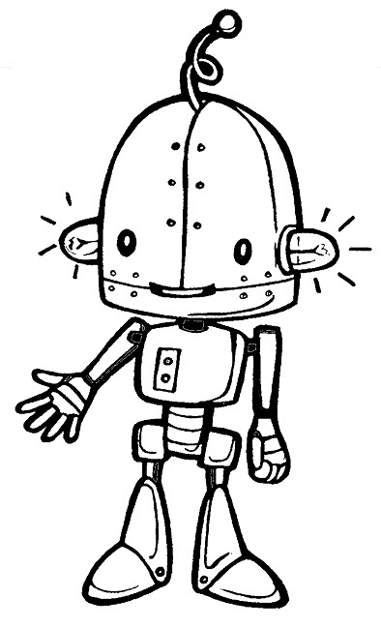
5 pts for creativity, teamwork, and ease of understanding

You will hand this paper in when you present, so don’t lose it!

