Our Energy Expo Presentation [Topic: _______________________]

Names: ______________________________, ______________________________,

______________________________, ______________________________,
Graded On |  | Group Points
Quality of Information |  | /15
 | All information correct = 15 points
 | A few errors = 10-14 points
 | Little information or many errors= 5-9 points
Engaging / Well-Presented |  | /10
 | Creative and has a model, prop, or demonstration= 10 points
 | Well-prepared, A little confusing = 7-9 points
 | Hard to understand, hear, or follow = 6 or fewer points
On Time  Time of Project= |  | /5
 | 5-7 minutes = 5 points
 | Within 1 minutes of time = 4 points
 | Within 2 minutes of time = 3 points
 | Over or under by more than 2 minutes = 2 points
Total

Comments:

Alternate Energy Research Project
Create a lesson covering a type of alternative energy. Your lesson will be from 5 – 7 minutes long, and should have a variety of ways in which you share your information. For example, A project on Geothermal energy might have a short video clip, a poster or diagram showing how geothermal energy works, and a PowerPoint or Prezi outlining the pros and cons or geothermal energy and listing examples of places that use it.

Please be creative when planning your lesson. Think of things that your teachers might use to make a lesson interesting, and try to follow their lead. Everyone in your group is responsible for some of the research, and everyone needs to speak during the presentation. Divide up the task load, and your project will be less stressful and have a better end result.
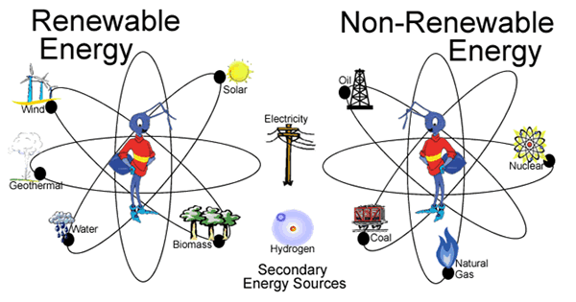

The topics are:
  - Biomass
  - Geothermal
  - Solar
  - Wind
  - Hydrogen
  - Hydropower (both running water and tides)

Your presentation should at least answer these questions.
- How does your process produce electricity?

- How much energy in the US is currently being produced this way

- What are some of the Pros and Cons of this energy source

- What are some ways that this energy source is currently being used

- Offer at least 3 ‘fun facts’ about your area of energy.

This project is due on: _____________________________________ and is worth 30 points
You will turn this paper in when you are ready to present

