Observing Mechanisms
Answer the questions from the screen on the other side, and then answer the question at the bottom of this page
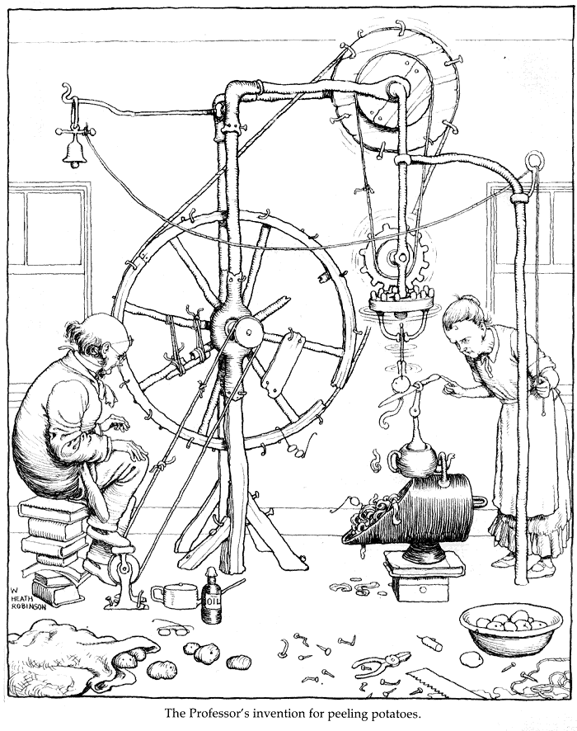
Circle and list 6 different mechanisms in the Rube Goldberg picture above and predict the purpose of each. Does the mechanism change speed, force, torque, direction, or type of movement?
Mechanism Location | Purpose

