RobotC Programming Help
- Before Programming Switches, Open a new page in Robot C and adjust the “Motor and Sensor setup” to GTT testbed.
- Programming a Switch | 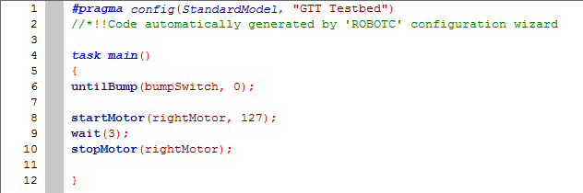
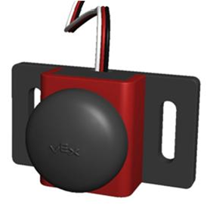
Choose “untilBump” to activate your switch. A bumpswitch should be plugged into Digital port #2

II. Programming a Potentiometer | 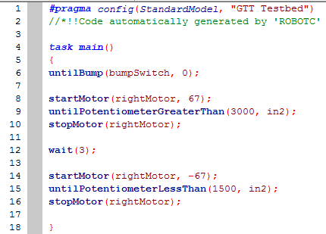
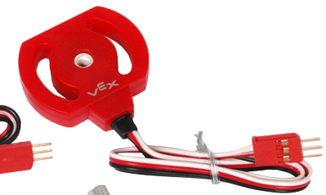
Choose “untilPotentiometerGreaterThan” or untilPotentiometerLessThan” to activate eteryour switch. A Potentiometer should be plugged into Analog port #2
When you program the Potentiometer (or the Line Tracker) you want to use the “debugger Window to see what value the sensor is reading. Get to the Debugger window by
1. Clicking “Download to Robot”
2. Then clicking: RobotDebugger Windows Sensors
After you click on “Debugger Windows” you will see these sensor values at the bottom of your screen. Watch the numbers change as you turn the Potentiometer or cover the Line Tracker

III. Programming a Line Tracker | 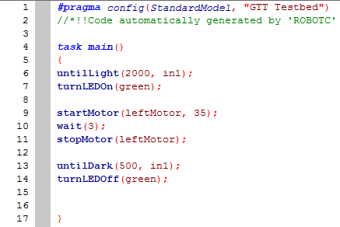
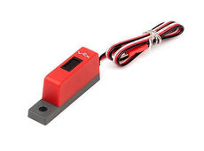
Choose “untilLight” or “untilDark” to activate your switch. A Line Tracker should be plugged into Analog port #1

IV. Writing an Open Loop Program | 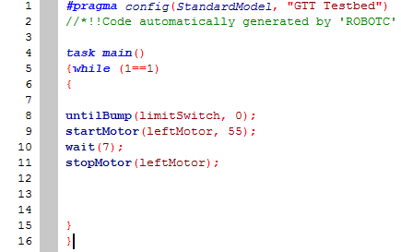
In order to keep a project working once you have pulled the orange cord, you need to turn your program into an “Open Loop” program.

